**Project Design Phase**

**Solution Architecture**

|  |  |
| --- | --- |
| **Date** | 27 june 2025 |
| **Team ID** | LTVIP2025TMID59882 |
| **Project Name** | TrafficTelligence : Advanced Traffic Volume Estimation with Machine Learning |
| **Maximum Marks** | 4 Marks |

**Solution Architecture:**

Traffic Intelligence: Advanced Volume Estimation Using Machine Learning" aims to enhance traffic volume estimation for urban planning and management. By collecting diverse traffic data and applying machine learning, the project seeks to provide real-time, accurate traffic volume predictions, historical analysis, and anomaly detection, ultimately contributing to more efficient and informed traffic management.

Our solution uses many advanced Machine learning Algorithms to address the Traffic Volume Estimation problem effectively.

Steps to be followed:-

1. Data Collection: Sensors, cameras, and IoT devices capture real-time traffic data.
2. Data Pre-processing: Clean and preprocess data to make an effective model.
3. Train Model: Using preprocessed data to make predictive models for forecasting traffic volume patterns for real-time estimations.
4. Test Model: To make sure that the model is accurate and efficient.
5. Integrating Model: To make a user facing applications so that the user can interact with the model.

**Solution Architecture Diagram**

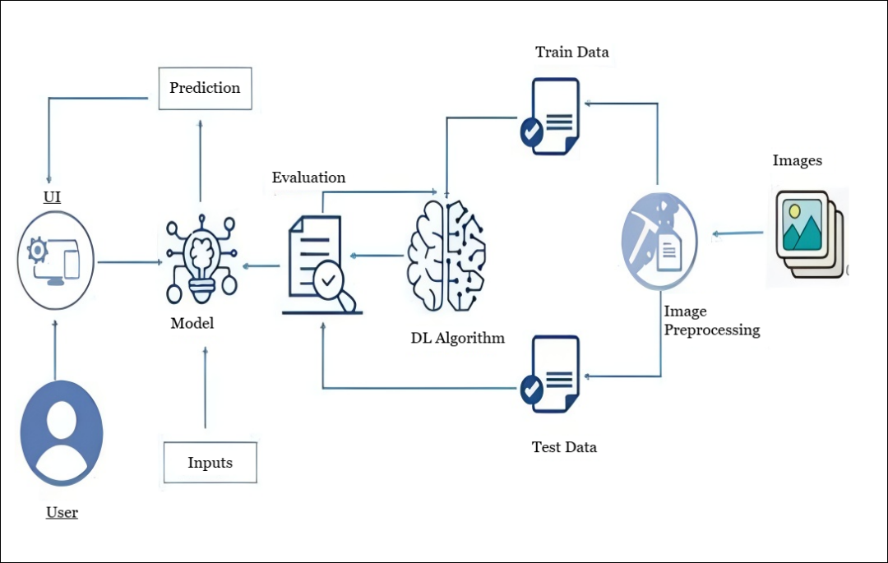

**Reference:** [**https://aws.amazon.com/blogs/industries/voice-applications-in-clinical-research-powered-by-ai-on-aws-part-1-architecture-and-design-considerations/**](https://aws.amazon.com/blogs/industries/voice-applications-in-clinical-research-powered-by-ai-on-aws-part-1-architecture-and-design-considerations/)